
Story

Date | 1 November 2026
Team ID
Project Name | EV Market Performance & Insights Platform
Maximum Marks | 5 Marks

By using stories in Tableau, you can effectively communicate complex data in a way that is both interactive and engaging, making it easier for the audience to follow along and understand the insights. It’s a tool for data storytelling, allowing you to present insights in a cohesive, engaging way that takes viewers through a logical progression of findings or analyses.
In Tableau, Story is a feature that allows you to create a sequence of dashboards, visualizations, and text to present data insights in a cohesive and narrative-driven way. It's like a slideshow within Tableau that guides the audience through a series of data points, helping them understand key insights, trends, or outcomes of your analysis.

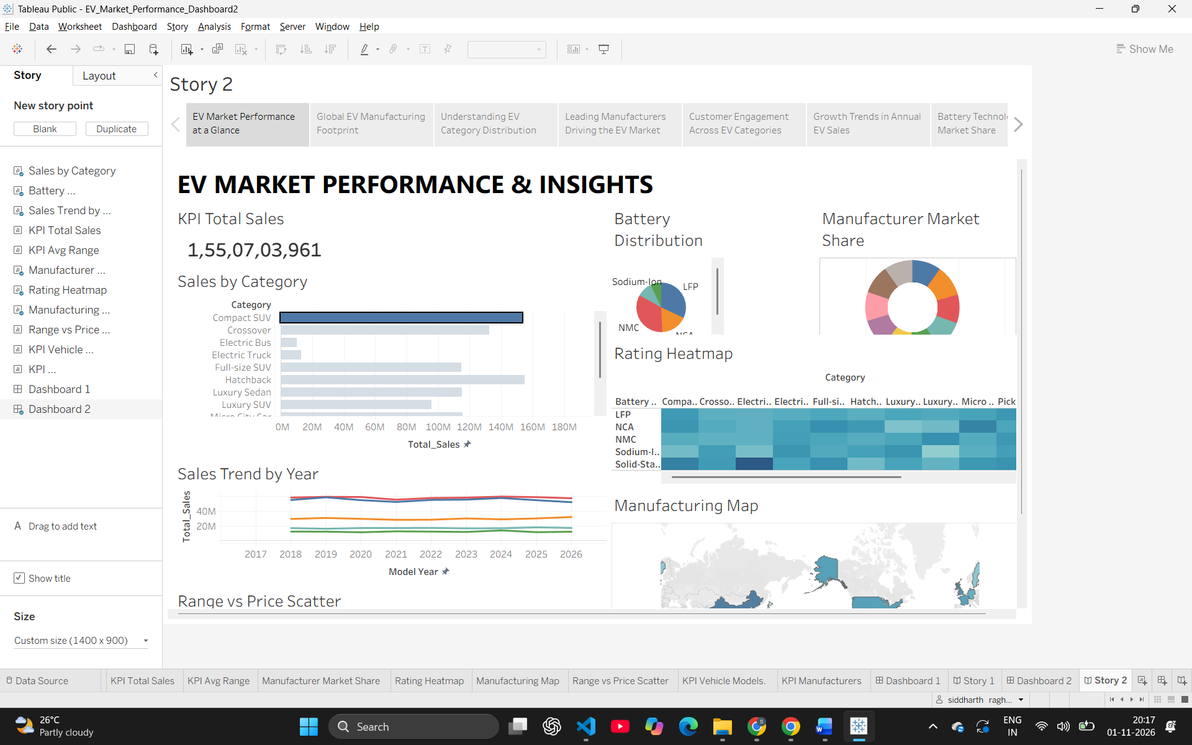

Observations:
- Category Dominance: The EV market is heavily driven by the Compact SUV category, which significantly outpaces other segments like Hatchbacks and Luxury Sedans in total sales volume.
- Battery Technology Shift: The story reveals that LFP (Lithium Iron Phosphate) and NMC (Nickel Manganese Cobalt) are currently the dominant battery technologies, with newer tech like Sodium-Ion still holding a smaller market share.
- Geographic Manufacturing Hubs: The manufacturing footprint map clearly shows that global EV production is highly concentrated in specific regions, primarily North America, Europe, and parts of Asia.
- Consistent Growth Trajectory: The historical sales trend line chart indicates a strong, uninterrupted upward trajectory in annual EV sales from 2017 through the projected 2026 timeline.

Activity 2:
Publish Story on Tableau Public and Paste Public link below
https://public.tableau.com/app/profile/siddharth.raghuwanshi6833/viz/EV_Market_Performance_story2/Story2?publish=yes

